` 

**JAIN COLLEGE OF BBA, BCA AND COMMERCE**, **BELAGAVI**

**BACHELOR’S OF COMPUTER APPLICATIONS**

A PROJECT REPORT ON

**“RAILMEDIHUB ASSISTANCE SYSTEM”**

Submitted in partial fulfillment of the requirement for the award of

Bachelor’s Degree of Computer Application for the year

2024-2025

**Submitted by**

**Vivek S Khainoor UUCMS: U15BR22S0021**

**Varsha Phulwale UUCMS: U15BR22S0023**

**Aishwarya Gurav UUCMS: U15BR22S0128**



**RANI CHANNAMMA UNIVERSITY, BELAGAVI**

**2024-2025**

**JAIN COLLEGE OF BBA BCA AND**

**COMMERCE,BELAGAVI**

**DEPARTMENT OF COMPUTER APPLICATIONS**



(Affiliated to Rani Channamma University, Belagavi & Recognized By Govt. of Karnataka)

**BACHELOR OF COMPUTER APPLICATIONS**

**(2024-2025)**

**A PROJECT REPORT ON**

**“RAILMEDIHUB ASSISTANCE SYSTEM”**

**Under the Guidance**

**Prof. Geeta Sakhare**

**Submitted by**

**Vivek S Khainoor UUCMS: U15BR22S0021**

**Varsha Phulwale UUCMS: U15BR22S0023**

**Aishwarya Gurav UUCMS: U15BR22S0128**

**JAIN COLLEGE OF BBA, BCA AND COMMERCE, BELAGAVI**

**DEPARTMENT OF COMPUTER APPLICATIONS**



Certificate

This is to certify that

**Vivek S Khainoor**

**Varsha Phulwale**

**Aishwarya Gurav**

Has satisfactorily completed the project work entitled

**“RailMediHub Assistance System”**

For the partial fulfillment of Bachelor Degree in Computer Applications

of Rani Channamma University, Belagavi

For the year 2024-2025

Internal Guide Head of Department Principal

**Prof. Geeta Sakhare Prof. Chaitanya. Raikar Prof. Sunil Desai**

**Examiners:**

1.____________________

2.____________________

**ACKNOWLEDGEMENT**

I take this opportunity to acknowledge the contribution of each individual who

has in some way or the other helped me in completing this project successfully.

I express my gratitude to our institute, Jain College of BBA, BCA & Commerce,

Belagavi Department of BCA and our beloved Principal Prof. Sunil Desai for

being the source of encouragement.

I also enhance our gratitude to Prof. Chaitanya N. Raikar, Head of Department,

and BCA for her constant inspiration and guidance and provided necessary

resources and working environment in the college.

I extend my deep sense of gratitude to Prof. Geeta Sakhare (Internal Guide)

for valuable guidance throughout project completion.

My expressions extend unbounded to thank our most beloved parents & family

members who have always been a moral support and strong pillars at every

stage of our life with cheer enthusiasm. I dedicate work to them.

Last but not least, I am thankful to almighty moral support, which helped you

during the successful completion of the project.

**Vivek S Khainoor**

**Varsha Phulwale**

**Aishwarya Gurav**

**Table Of Contents.**

|  |  |  |
| --- | --- | --- |
| **Sl No** | **Name of the Contents** | **Page No** |
| **1** | Certificate of Internship | **6** |
| **2** | Acknowledgement | **9** |
| **3** | Information about the Company | **10** |
| **4** | Information about the internship position | **12** |
| **5** | Description of internship Experience | **13** |
| **6** | Conclusion | **16** |

**CERTIFICATE OF INTERNSHIP**

**CERTIFICATE OF INTERNSHIP**

**CERTIFICATE OF INTERNSHIP**

**Acknowledgement**

I am immensely grateful to Infynow Business Solutions for providing me with an exceptional internship opportunity that has significantly contributed to my professional growth. The experience gained during this period has been invaluable in shaping my career as a Full Stack Developer.I would like to express my deepest appreciation to Mr. Karthik Hansi, my mentor and supervisor, for their unwavering guidance, support, and encouragement throughout my internship. Their expertise and mentorship have been instrumental in my development as a developer. Their patience in explaining complex concepts and their willingness to share their knowledge have been invaluable to my learning process. I am also thankful to the entire team at Infynow Business Solutions for creating a collaborative and supportive work environment. The opportunity to work alongside talented professionals has been truly inspiring. Their knowledge and insights have enriched my learning experience. I am particularly grateful for the hands-on experience I gained in front-end development, back-end development and database management. The projects I contributed to have provided me with a solid

foundation in HTML, CSS, Bootstrap, JavaScript, Django, Python and MySQL.

I would also like to acknowledge the support and encouragement of professors, colleagues who contributed to success. Their belief in my abilities has motivated me to strive for excellence.

I am confident that the skills and knowledge acquired during my internship will be invaluable as I embark on my professional journey.

**Information about the Company**

**INFYNOW HISTORY**

Infynow head office is located in Belagavi, Karnataka – founded in the year of 2019, and we support

remote sites across multiple cities with three branches. We place our focus on leveraging our

infrastructure and footprint to support a broad spectrum of organisations with rapid deployment and

emerging technologies. Over the years, Infynow has evolved into an advanced solutions provider,

focused on servicing customers and creating value through long term relationships that we build. We

have established and fixed costs, based on our customer needs and budget.

**INFYNOW PROFILE**

Infynow Software Solutions LLP is a leading IT service providing company based in Belagavi India. We

offer a complete range of services that incorporates Website design and Development, Software Solutions,

Application development, Digital Marketing and Internship and Project Training. We help businesses

overcome their challenges and stay ahead of the competition by strengthening with the latest and cutting

edge technologies. For local businesses, we are dedicated to finding creative and affordable premium

solutions to build their presence and expand their business. And with a resolved focus on clients, our IT

solutions will empower businesses in planning and executing business strategies that transform

investments into economic value and helps our clients to achieve long-term growth.

**Ultimately, Infynow strives for your excellence!**

We strive to deliver more efficient, effective and relevant quality services and solutions tailored to the

increasingly complex demands of organisations, in order to boost productivity of operations and to

maximise value for our customers. Infynow also strives towards technology that provides a real advantage

to a business. The most Powerful connection that a business can make is through all its stakeholders.

Infynow binds together business and technology.

**INFYNOW BUSINESS**

Infynow is dedicated to doing business in an ethical and sustainable manner to meet

the needs of a vast range of businesses and industries. We combine our industry

knowledge, expertise and best practice with our clients’ needs to design and develop

tailor-made solutions depending on your requirements. We recognize that people

are part of IT and that the effective combination of these two, contributes to the

success of any business.

**INFYNOW WORKPLACE**

At Infynow there is a focus on skills and development. We are dedicated to unlock

the potential of all our employees through continuous skill development and in

house training. With the skills development of all our employees, we foster a

productive and vibrant workplace in order to accelerate growth. Infynow ever

increasing workforce is aligned with its rate of growth and is continuously focused

on the latest technology to improve the quality of all services and products that we

offer.

**Infynow provides solutions that enable business and empower our clients :**

● Enable clients to focus on their business by providing a practical IT

solution by creating an Environment for success.

● Minimise risk of data loss, downtime, security threats and provide

redundancy at the same time, by ensuring your business operations

continue through virtualization and automation.

● Improve overall client’s service and satisfaction, Increase

communication between all stakeholders which is essential with all

the current dynamic business challenges that all businesses face

today such as globalisation and increased worker mobility.

**INFYNOW INTERNSHIP AND PROJECT TRAINING**

Right skills and opportunities are the 2 main essential requirements to urge

on the road of success that ultimately results in a path of constant learning. Our

Internship provides students hands-on experience to work in their desired field to

get many opportunities. We train students to implement their theoretical knowledge

gained from institutions within real-time projects and

gain valuable experience which will help them to be qualified for the desired job.

InfynowSoftware Solutions LLP will provide students a chance to work with the

team of Software Developers. Our core focus is to prepare the students technically

&inter-personally by carrying out live projects and effectively mentor candidates

for taking challenges and resolving them successfully within our Live projects &

Internship Programs.

Being an intern means quite getting involved within the day-to-day running of the

corporation. Asan intern, students will get exposure to real time projects and

challenges during a vibrant environment and gain world experience.

**INFORMATION ABOUT THE**

**INTERNSHIP POSITION**

**1. Introduction**

● **The Role of Student Interns**: Student internships provide a crucial bridge

between academic learning and practical, hands-on experience. By working

within a company, students transition from theoretical knowledge to applying

their skills in a real-world environment. This process is instrumental in shaping

their professional identity and understanding of the industry.

**2. Working in a Company**

● **Assigned Responsibilities**:

o **Real Projects**: Unlike academic assignments, the tasks given during

internships are part of ongoing projects within the company. Students

often work on actual client projects, contributing to deliverables that

impact the company's operations.

o **Team Collaboration**: Interns are integrated into teams where they

collaborate with experienced professionals. This team dynamic allows

students to learn from their peers, understand workflow processes, and

adapt to professional standards.

● **Learning Company Culture**:

o **Workplace Etiquette**: Interns quickly learn the norms and expectations

of a professional environment, including communication protocols,

meeting etiquette.

o **Understanding Hierarchies**: Navigating the organisational structure

helps students understand reporting lines, the importance of various

roles, and the chain of command within a business setting.

● **Skill Application and Development**:

o **Technical Skills**: Interns apply the technical knowledge they have

acquired in college to solve real-world problems, such as coding,

designing, or conducting research.

o **Soft Skills**: Communication, teamwork, time management, and

problem-solving are key areas where interns grow as they handle

workplace challenges.

**DESCRIPTION OF INTERNSHIP**

**EXPERIENCE**

**1. Project Assignments**

● **Scope of Work**:

o **Introduction to Projects**: Interns are often introduced to projects

gradually, starting with smaller tasks that align with their skill level, and

progressively taking on more complex responsibilities.

● **Mentorship and Guidance**:

**Supervisor Role**: Each intern is usually assigned a supervisor or

mentor who provides guidance, feedback, and support. This mentor

plays a crucial role in helping the intern navigate challenges and learn

industry-specific best practices.

**Peer Learning**: Interns also benefit from working closely with

colleagues who may be recent graduates themselves, sharing tips and

experiences that help ease the transition from student to professional.

● **Tools and Technologies**:

**Hands-on with Industry Tools**: Interns are exposed to the software,

tools, and technologies used within the industry, such as version control

systems, design software, and project management tools. This exposure

is vital for understanding industry standards.

**Learning New Skills**: In many cases, interns need to learn new tools

and technologies that they were not exposed to during their academic

studies. This continuous learning process helps interns stay adaptable

and improves their technical proficiency.

**2. Measuring Growth and Impact**

● **Feedback Loops**:

**Regular Evaluations**: Interns receive ongoing feedback from their

supervisors and peers. This feedback helps them understand their

strengths and areas for improvement, enabling them to adjust their

approach and refine their skills.

**Self-Assessment**: Many companies encourage interns to self-reflect on

their progress, identifying their personal and professional growth areas

throughout the internship.

● **Impact on the Company**:

**Contributions**: Interns often bring fresh perspectives and ideas that can

lead to innovative solutions within the company. Their contributions

can range from streamlining processes to assisting in creative

brainstorming sessions.

**Long-Term Value**: Internships can lead to job offers, as companies

often see the potential in interns and want to retain them as full-time

employees after graduation.

**HTML (HyperText Markup Language)**

● **Purpose**: HTML is the foundational language used to create the structure of

web pages. It defines the content and layout of a webpage by using elements

like headings, paragraphs, lists, links, images, and more.

● **Structure**: HTML uses tags enclosed in angle brackets, such as <html>,

<head>, <body>, <div>, and <p>. These tags create the skeleton of the

webpage.

**CSS (Cascading Style Sheets)**

● **Purpose**: CSS is used to style and layout web pages. It controls the visual

presentation of HTML elements, including colors, fonts, spacing, and

positioning.

● **Structure**: CSS consists of selectors (targeting HTML elements) and

declarations (defining the styles). A declaration block is enclosed in curly

braces {} and contains property-value pairs.

**JavaScript**

● **Purpose**: JavaScript is a programming language used to add interactivity and

dynamic behaviour to web pages. It allows developers to manipulate HTML

and CSS, respond to user actions, and interact with web servers.

● **Structure**: JavaScript code is written in <script> tags within HTML or in

separate .js files. It uses variables, functions, loops, and conditionals to perform

actions.

**Bootstrap**

● **Purpose**: Bootstrap is a popular front-end framework that provides pre

designed components and utilities for building responsive and mobile-first

websites. It includes CSS classes and JavaScript plugins for layout, typography,

forms, buttons, navigation, and more.

● **Structure**: Bootstrap uses a grid system for layout, with rows and columns,

and predefined classes to style elements. It allows for quick and consistent

design across different browsers and devices.

**Conclusion**

My internship at Infynow Business Solutions has been an invaluable experience that has significantly enhanced my skills and understanding as a Full Stack Developer. The hands-on exposure to front-end and back-end development, along with database

management, has provided me with a solid foundation in HTML, CSS, Bootstrap,

JavaScript, Django, Python, and MySQL. Working on real-world projects and

collaborating with a talented team has not only honed my technical skills but also

enriched my understanding of professional work environments.

The guidance and mentorship I received, particularly from Mr. Karthik Hansi, have been

crucial in navigating the challenges and learning opportunities during my internship. The

collaborative and supportive atmosphere at Infynow Business Solutions allowed me to

grow both professionally and personally.

This internship has prepared me to confidently embark on my professional journey,

equipped with the knowledge and skills needed to excel in the field of Full Stack

Development. I am deeply appreciative of the opportunity to contribute to and learn from

such a dynamic and forward-thinking company.

INDEX

|  |  |  |
| --- | --- | --- |
| SL NO | TOPIC | PAGE NO |
| 1 | Introduction | 21 |
| 2 | System requirements specification | 26 |
| 3 | System Design | 30 |
| 4 | Database Design | 40 |
| 5 | Detailed Design | 45 |
| 6 | Program Code Listing | 54 |
| 7 | User Interface | 65 |
| 8 | Testing | 75 |
| 9 | Conclusion | 77 |
| 10 | Limitations | 78 |
| 11 | Scope Of Enhancement | 78 |

**LIST OF CONTENTS**

**1. Introduction**

a. Introduction of the System

i. Project Title

ii. Category

iii. Overview

b. Background

i. Introduction of the Company

ii. Brief note on Existing System

c. Objectives of the System

d. Scope of the System

e. Structure of the System

f. System Architecture

g. End Users

h. Software/Hardware used for the development

i. Software/Hardware required for the implementation

**2. SRS**

a. Introduction (Brief write-up about SRS)

b. Overall Description

i. Product perspective

ii. Product Functions

iii. User characteristics.

iv. General constraints

v. Assumptions

c. Special Requirements (Software / Hardware-if any)

d. Functional requirement.

i. Module 1

ii. Module 2

e. Design Constraints

f. System Attributes

g. Other Requirements (if any)

**3. System Design (Functional Design)**

a. Introduction (brief write-up about System Design)

b. Assumptions and Constraints

c. Functional decomposition

d. Description of Programs

i. Context Flow Diagram (CFD)

ii. Data Flow Diagrams (DFDs–Level 0, Level 1, Level 2)

e. Description of components

i. Functional component 1

ii. Functional component 2

**4. Database Design (or Data structure)**

a. Introduction (brief write-up about Database design)

b. Purpose and scope

c. Table Definition

d. ER diagram

**5. Detailed Design (Logic design of modules)**

a. Introduction (brief write-up about Database design)

b. Structure of the software package (structure chart)

c. Modular decomposition of the System

i. Module1

1. Inputs

2. Procedural details

3. File I/O interfaces

4. Outputs

5. Implementation aspects (if any)

ii. Module 2

**6. Program code listing**

a. Database connection

b. Authorization / Authentication

c. Data store / retrieval /update

d. Data validation

f. Named procedures / functions

g. Interfacing with external devices (if any)

h. Passing of parameters

i. Backup/recovery

j. Internal documentation

**7. User Interface (Screens and Reports)**

a. Login

b. Main Screen / Home page

c. Menu

d. Data store / retrieval / update

e. Validation

f. View

g. On screen reports

h. Data Reports

i. Alerts

j. Error messages

**8. Testing**

a. Introduction (brief write-up about Software Testing)

i. Unit Testing

ii. Integrate Testing

iii. System Testing

b. Test Reports

• Conclusion

• Limitations

• Scope for enhancement (future scope)

• Abbreviations and Acronyms (list)

• Bibliography / References (list in specified format)

**INTRODUCTION**

1. **Introduction of the System**

#### ****i. Project Title:****

**RailMediHub Assistance System**

#### ****ii. Category:****

Web-Based Application – Healthcare/Medicine Delivery System

#### ****iii. Overview:****

RailMediHub Assistance System is a web-based solution aimed at delivering essential medicines to railway passengers during their journey. Passengers can book required medicines online and select the station where they want the delivery. The system helps connect passengers with nearby pharmacies located at or near the railway stations and ensures timely delivery. It bridges the gap in healthcare accessibility for travelers, especially during emergencies.

1. **Background**

#### ****i. Introduction of the Company:****

This system is developed as a final-year academic project by BCA students under the guidance of the Department of Computer Applications. The goal is to solve a real-world healthcare logistics problem using a technology-driven approach.

#### ****ii. Brief Note on Existing System:****

Currently, passengers have no reliable or organized way to get medicines while traveling by train. If they fall sick during the journey or forget their medications, they are left without options. There is no system that connects them to pharmacies en route, leading to health risks and inconvenience.

1. **Objectives of the System**

* To provide a platform for booking medicines during train travel.
* To facilitate medicine delivery at selected railway stations.
* To connect passengers with nearby pharmacies.
* To improve healthcare access for railway travellers.
* To manage orders, deliveries, and pharmacy data efficiently.

1. **Scope of the System**

* The system supports users in requesting medicine deliveries at specific railway stations.
* It manages medicine data, user orders, pharmacy details, and delivery scheduling.
* The project currently does not include live train tracking, payment gateway, or authentication.
* The system can be expanded to include real-time tracking and online payments in future versions.

1. **Structure of the System**

* **User Module** – Allows passengers to book and view medicine delivery details.
* **Pharmacy Module** – Allows pharmacies to manage medicines and fulfill orders.
* **Admin Module** – Manages users, pharmacies, and order status.
* **Database** – Stores information about medicines, stations, users, and orders.

1. **System Architecture**

**Three-Tier Architecture:**

1. **Presentation Layer (Frontend):**  
   HTML, CSS, JavaScript – for user interface and interactions.
2. **Application Layer (Backend):**  
   PHP – for handling business logic, form submissions, and communication with the database.
3. **Database Layer:**  
   MySQL – stores data related to users, pharmacies and medicine orders.
4. **End Users**

* **Passengers/Users:** Can search for medicines and place orders.
* **Pharmacy Staff:** View and manage incoming orders for fulfillment.
* **Administrator:** Manages all users, pharmacies, and the system’s smooth functioning.

**h. Software/Hardware Used for the**

**Development**

**Software:**

* Frontend: HTML, CSS, JavaScript
* Backend: PHP
* Database: MySQL
* IDE: Visual Studio Code / Sublime Text
* XAMPP for local server setup

**Hardware:**

* Development machine with minimum 4GB RAM
* Web browser for testing
* Stable internet connection

**i. Software/Hardware Required for the**

**Implementation**

**Software:**

* Web browser (Chrome, Firefox)
* Web server (Apache via XAMPP or similar)
* PHP and MySQL support
* Operating System: Windows/Linux

**Hardware:**

* Any device with internet capability (PC, tablet, or mobile)
* Minimum 4GB RAM and Dual-core processor for server hosting
* Localhost or server machine to deploy the application

**Software Requirements Specification (SRS)**

**Software Requirements Specification (SRS)**

**a. Introduction**

The SRS defines the functional and non-functional requirements of the RailMediHub Assistance System. It outlines how the system should behave and what it should achieve, serving as a reference for both developers and stakeholders.

**b. Overall Description**

**i. Product Perspective**

RailMediHub is a standalone web application aimed at enabling medicine delivery to railway passengers. It connects users, vendors, and railway authorities, unlike general e-commerce systems, and is tailored for railway use cases.

**ii. Product Functions**

* **Medicine Request Submission:** Users specify medicines and delivery stations.
* **Vendor Response:** Vendors confirm availability and dispatch orders.
* **Order Tracking:** Status updates on delivery.
* **Railway Coordination:** Station staff facilitate handover.
* **Database Management:** Secure storage of user, vendor, and delivery data.

**iii. User Characteristics**

* **Passengers:** Require a simple interface to place and track orders.
* **Supplier/Vendor:** Manage incoming medicine requests and confirm deliveries.
* **Railway Staff:** Coordinate the delivery and ensure medicines reach passengers.

**iv. General Constraints**

* No user authentication, payment gateway, or live train tracking.
* Accessible through standard web browsers.
* Limited to the predefined user roles and functionalities.

**v. Assumptions**

* Users have internet access during train travel.
* Vendors and railway authorities are cooperative.
* Medicine availability and timely dispatch are ensured by vendors.

**c. Special Requirements**

**Software:**

* HTML, CSS, JavaScript (Frontend)
* PHP (Backend)
* MySQL (Database)

**Hardware:**

* Basic development system (4GB RAM, modern browser, internet).
* No specialized hardware needed for implementation.

**d. Functional Requirements**

**i. Module 1 – Medicine Request Handling**

* Users submit a form with medicine details and desired delivery station.
* System stores and validates the request.
* Confirmation is sent to the user.

**ii. Module 2 – Supplier/Vendor and Delivery Management**

* Vendors view requests, confirm availability, and update status.
* The system enables order tracking.
* Station staff see incoming deliveries and mark them as handed over.

**e. Design Constraints**

* Must follow three-tier architecture (frontend, backend, database).
* Use only specified technologies (PHP, MySQL, HTML/CSS/JS).
* No third-party APIs or plugins for authentication or tracking.

**f. System Attributes**

* **Usability:** User-friendly UI, accessible across devices.
* **Reliability:** High uptime, with fallback and error handling.
* **Scalability:** Can be expanded with features like payment and authentication.
* **Maintainability:** Modular code and clear documentation.

**g. Other Requirements (If any)**

* Security: Role-based access for vendors and staff.
* Backup: Regular database backups for disaster recovery.
* Data Integrity: Validation and sanitization to prevent SQL injection and XSS.

**System design**

**(Functional Design)**

**System Design (Functional Design)**

**a. Introduction**

The **RailMediHub Assistance System** is designed to deliver essential medicines via railways to remote or underserved areas. The system facilitates users in requesting medicines online, and the delivery is arranged through railway logistics. It streamlines requests, dispatches, and delivery tracking, providing a centralized platform for users, medical suppliers, and railway dispatch units.

**b. Assumptions and Constraints**

**Assumptions**:

* Users have access to an internet connection and a device to access the website.
* Medicine delivery is only available in areas accessible via the railway network.
* The admin will verify orders before dispatch.

**Constraints**:

* No real-time train tracking is included.
* No online payment gateway integration (Cash on Delivery assumed).
* Limited to certain geographical zones served by the railway.

**c. Functional Decomposition**

* **User Module**: Register, request medicine, check delivery status.
* **Admin Module**: Approve requests, manage inventory and logistics.
* **Pharmacy/Distributor Module**: Upload medicine stock, dispatch goods.
* **Delivery Module**: Assign railway routes and delivery tracking.

**d. Description of Programs**

**i. Context Flow Diagram (CFD)**

* Shows a high-level interaction:
  + User places a medicine request.
  + Admin verifies and processes the request.
  + Medicine is dispatched via railway.
  + User receives delivery.

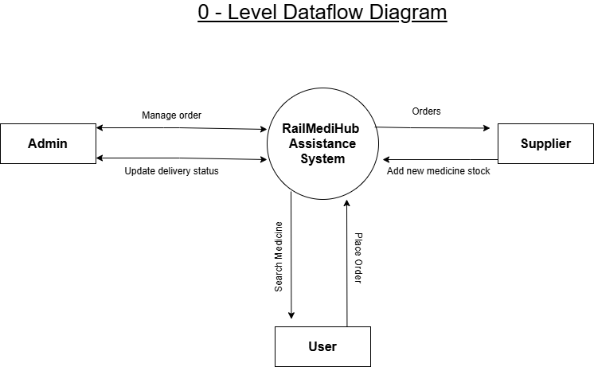

**ii. Data Flow Diagrams (DFDs)**

* **Level 1**: Breaks into modules like User Registration, Medicine Request, Admin Approval, etc.

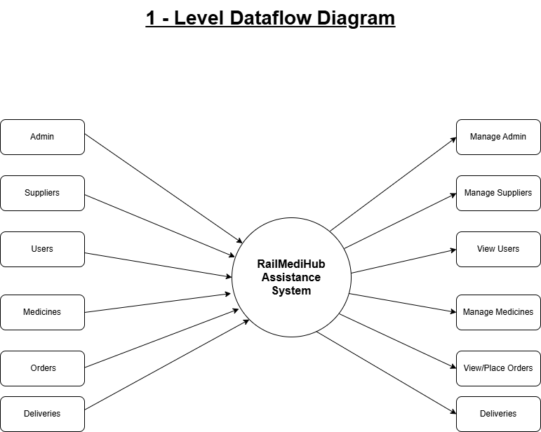

* **Level 2**: Further decomposes modules like Inventory Check, Route Assignment, etc.

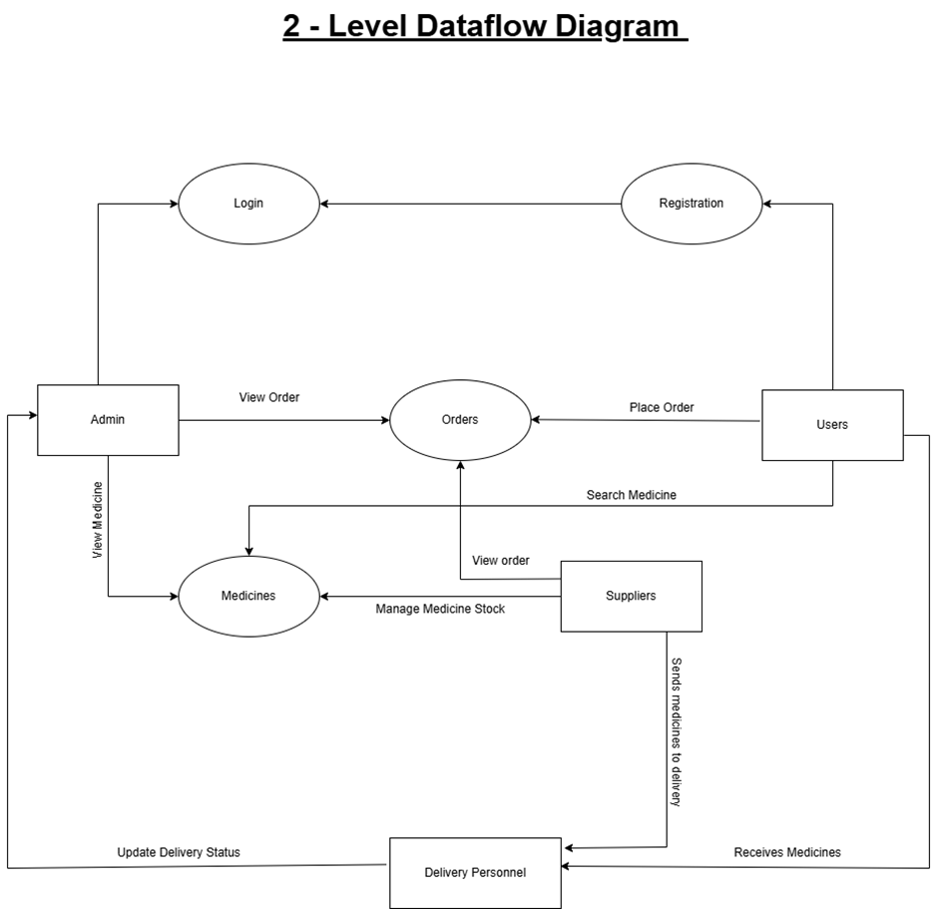

**Sequence Diagram**

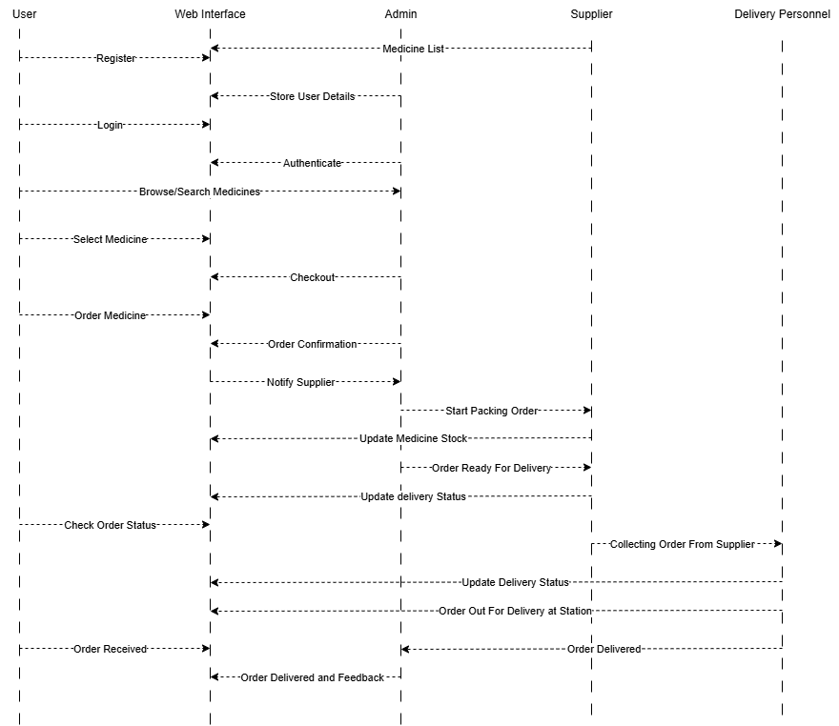

**Activity Diagram**

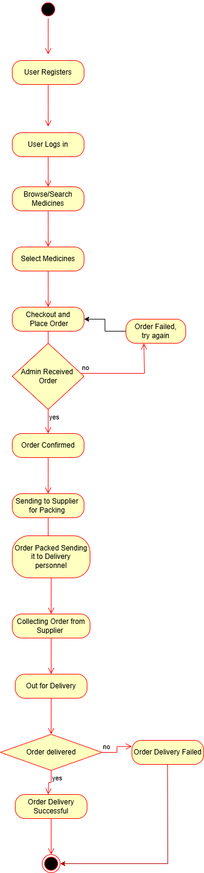

**e. Description of Components**

**i. Functional Component 1 – Medicine Request and Dispatch**

* User searches and requests available medicines.
* Admin verifies stock and approves request.
* Request is sent to pharmacy for packaging and delivery scheduling.

**ii. Functional Component 2 – Admin and Logistics Management**

* Admin manages user data, medicine stock, and delivery scheduling.
* Logistics module generates basic delivery reports and updates status.

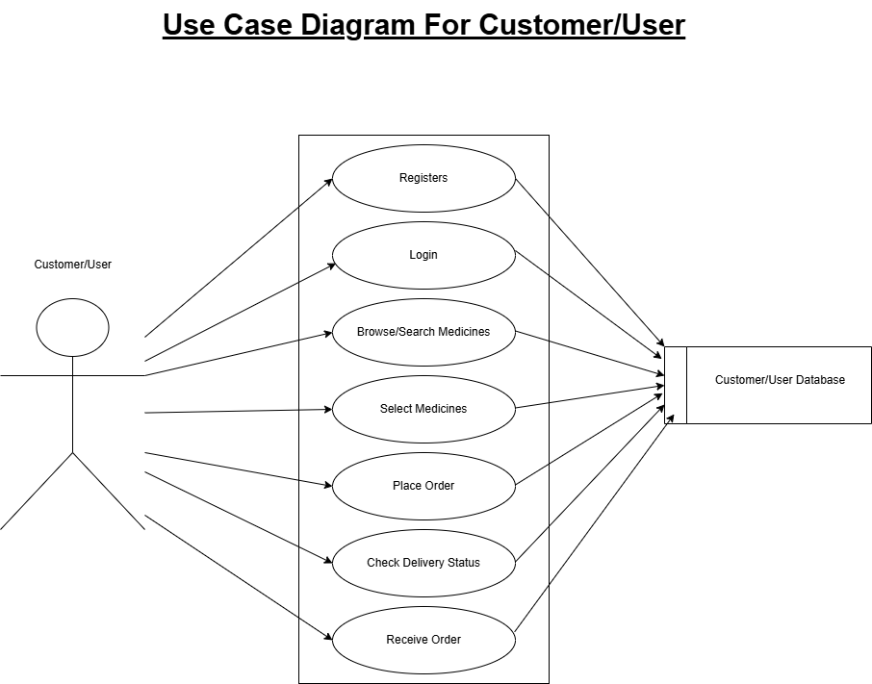

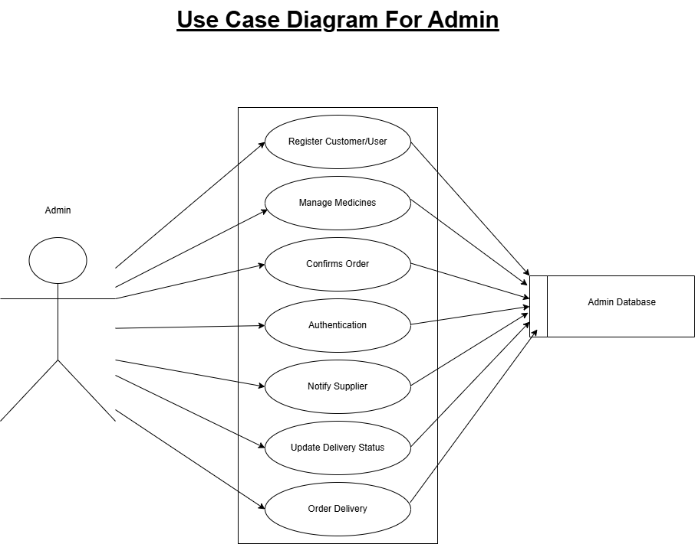

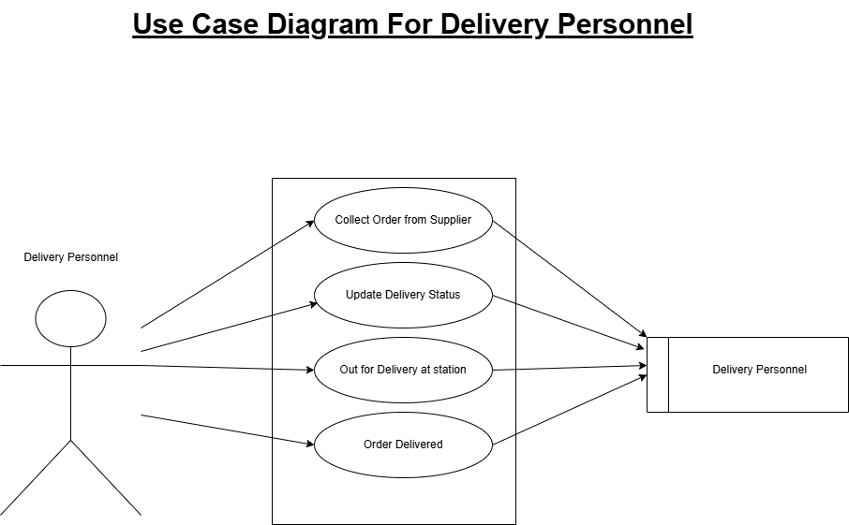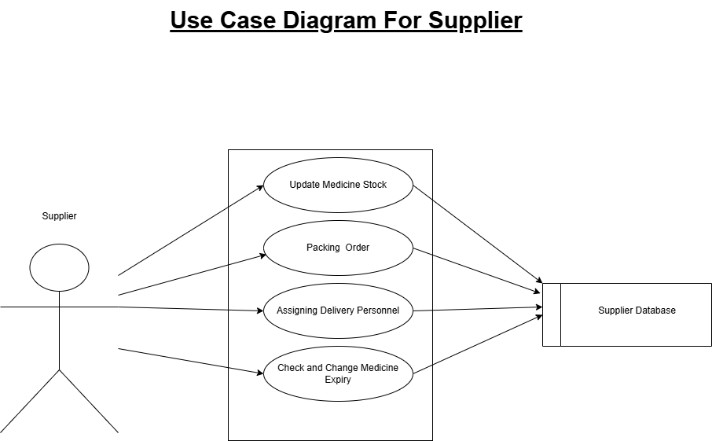

**Database Design**

**Database Design**

**a. Introduction**

The database design supports storing user details, medicine inventory, order requests, and delivery schedules. It ensures consistency, reliability, and scalability of data operations across the system.

**b. Purpose and Scope**

The purpose of the database is to:

* Maintain records of users, orders, and deliveries.
* Store medicine stock details from pharmacies.
* Track delivery operations without real-time train tracking.

**c. Table Definition**

1. Users Table

| **Field Name** | **Data Type** | **Description** | **Constraints** |
| --- | --- | --- | --- |
| user_id | INT | Unique ID for the user | Primary Key |
| name | VARCHAR | Full name of the user | Not Null |
| email | VARCHAR | User's email address | Unique, Not Null |
| phone | VARCHAR | User's contact number | Not Null |
| address | TEXT | Delivery address | Not Null |

**2. Medicines Table**

| **Field Name** | **Data Type** | **Description** | **Constraints** |
| --- | --- | --- | --- |
| medicine_id | INT | Unique ID for the medicine | Primary Key |
| medicine_name | VARCHAR | Name of the medicine | Not Null |
| description | TEXT | Description of the medicine | Optional |
| price | DECIMAL | Price per unit | Not Null |
| stock_quantity | INT | Available stock count | Not Null |
| pharmacy_id | INT | Linked pharmacy supplying it | Foreign Key |

**3. Medicines Table**

| **Field Name** | **Data Type** | **Description** | **Constraints** |
| --- | --- | --- | --- |
| medicine_id | INT | Unique ID for the medicine | Primary Key |
| medicine_name | VARCHAR | Name of the medicine | Not Null |
| description | TEXT | Description of the medicine | Optional |
| price | DECIMAL | Price per unit | Not Null |
| stock_quantity | INT | Available stock count | Not Null |
| pharmacy_id | INT | Linked pharmacy supplying it | Foreign Key |

s

**4. Delivery Table**

| **Field Name** | **Data Type** | **Description** | **Constraints** |
| --- | --- | --- | --- |
| delivery_id | INT | Unique ID for delivery record | Primary Key |
| order_id | INT | Related order ID | Foreign Key |
| dispatch_date | DATE | Date of dispatch via railway | Not Null |
| expected_delivery_date | DATE | Expected delivery date | Not Null |
| delivery_status | VARCHAR | Status (In Transit, Delivered) | Default: In Transit |

**d. ER Diagram**

The ER Diagram would include these entities:

* **User** → places and view→ **Order**
* **Order** → contains → **Medicine**
* **Medicine** → provided by → **Suppliers**
* **Admin** → manages→ **Orders**
* **Admin** → manages→ **Medicines**

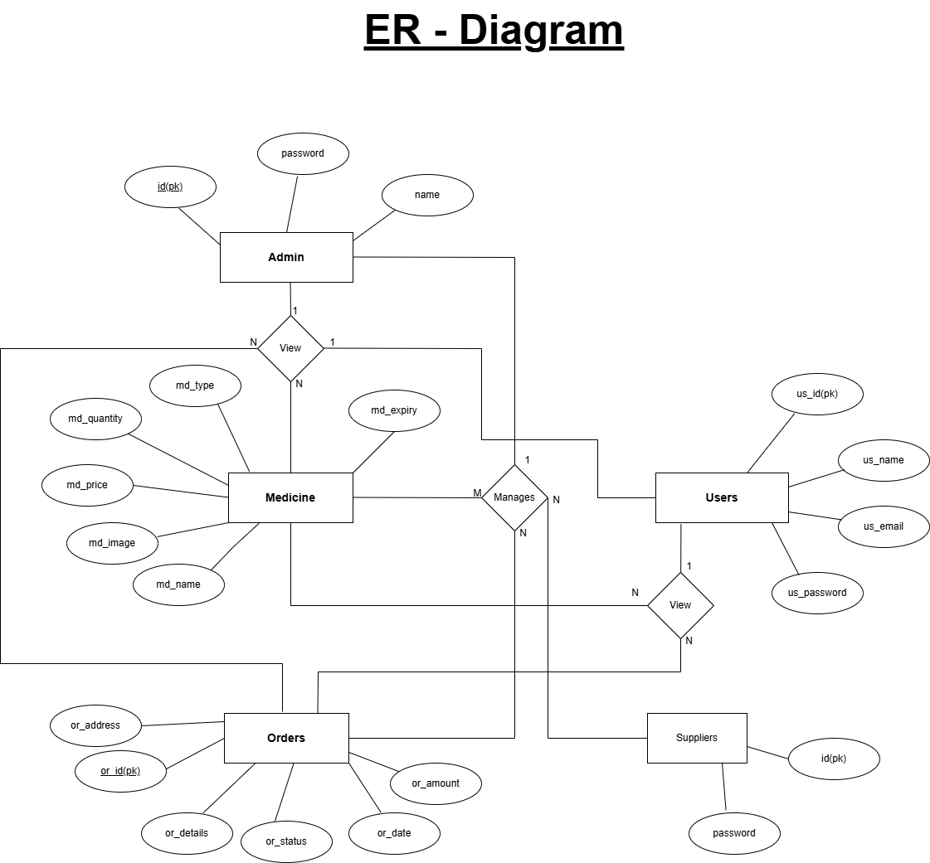

**Detailed Design**

**(Logic Design of Modules)**

**Detailed Design (Logic Design of Modules)**

**a. Introduction**

The database is designed to store and manage essential data such as user profiles, medicine inventory, orders, and delivery details. It supports efficient data retrieval for searching medicines, confirming availability, and placing orders. The relational database model is used with MySQL to ensure structured and normalized data handling across modules.

**b. Structure of the Software Package**

* **Login Module**: Authenticates all user roles.
* **User Module**: Searches medicines, places orders.
* **Order Management Module**: Handles order flow.
* **Pharmacy/Supplier Module**: Manages inventory and dispatch.
* **Admin Module**: Oversees the system.

**c. Modular Decomposition of the System**

#### Module 1: User Module

#### 1. Inputs:

#### User login credentials (username, password)

#### Search keyword for medicine

#### Selected medicine

#### Train number, coach, and berth (for delivery)

#### User contact information

#### 2. Procedural Details:

#### User logs into the system via the login module.

#### Enters search terms to find required medicine.

#### System queries the pharmacy database for availability.

#### User selects the medicine and fills in delivery details.

#### System records the order and passes it to the Order Management Module.

#### 3. File I/O Interfaces:

#### Database Read:

#### users – for user login and profile info.

#### medicines – to fetch available medicines.

#### pharmacy_inventory – to verify medicine stock.

#### Database Write:

#### orders – stores user order information.

#### order_tracking – logs tracking info for each order.

#### 4. Outputs:

#### Search results showing medicine availability.

#### Confirmation message with order summary and tracking ID.

#### Error messages if login fails or medicine is unavailable.

#### Display of user’s previous order history.

#### 5. Implementation Aspects:

#### Frontend: HTML, CSS, JavaScript for user interface and dynamic interactions.

#### Backend: PHP used to process form inputs, search logic, and insert orders into the database.

#### Module 2: Order Management Module

#### 1. Inputs:

#### Order details received from the User Module:

#### Selected medicine

#### Delivery information (train number, coach, berth)

#### User contact details

#### Pharmacy availability and location (from Pharmacy Module)

#### 2. Procedural Details:

#### Receive the confirmed order from the User Module.

#### Validate and store order details in the orders table.

#### Assign the order to an appropriate pharmacy based on medicine availability and delivery feasibility.

#### Generate a unique tracking ID for the order.

#### Update order status as it moves through different stages: *Pending → Dispatched → Delivered*.

#### Notify the pharmacy to initiate packing and dispatch.

#### Periodically update the status and notify the user.

#### 3. File I/O Interfaces:

#### Database Read:

#### orders – to fetch new orders and update status.

#### pharmacy_inventory – to verify availability before pharmacy assignment.

#### pharmacies – to determine dispatch location.

#### Database Write:

#### order_tracking – updates order status with timestamps.

#### notifications – logs messages sent to users and pharmacies.

#### 4. Outputs:

#### Order assignment to pharmacy with dispatch request.

#### Tracking ID and current order status.

#### Notifications to users about dispatch and delivery status.

#### Order management logs for admin review.

#### 5. Implementation Aspects:

#### Backend: PHP handles the logic for order assignment, status updates, and notifications.

#### Database: MySQL used to store order, tracking, and dispatch records.

#### Automation: Cron jobs or PHP timers can be used to simulate order status updates.

#### Error Handling: Ensures fallback if the primary pharmacy is out of stock.

#### Notifications: SMS/email logic (optional) can be added for real-time updates to users.

**Module 3: Pharmacy/supplier Module**

**1. Inputs:**

* Order details assigned by the Order Management Module:
  + Medicine name
  + Quantity required
  + User delivery details (train number, coach, berth)
* Inventory data of the pharmacy

**2. Procedural Details:**

* Receive order request from the Order Management Module.
* Check medicine availability in the pharmacy’s inventory.
* If available:
  + Reserve the required quantity.
  + Prepare the order package for delivery.
  + Update inventory to reflect reserved quantity.
* Confirm the order is ready for dispatch.
* Notify the Order Management Module of the dispatch status.
* Handover to railway staff/courier for in-train delivery.

**3. File I/O Interfaces:**

* Database Read:
  + orders – to get medicine and delivery details.
  + pharmacy_inventory – to check and verify stock levels.
* Database Write:
  + pharmacy_inventory – to update quantity after reservation.
  + order_tracking – to update status (e.g., "Ready for Dispatch", "Dispatched").

**4. Outputs:**

* Confirmation message of medicine availability.
* Dispatch notification sent to Order Management Module.
* Updated inventory records.
* Delivery readiness status in tracking system.

**5. Implementation Aspects:**

* Backend: PHP code processes inventory checks and updates order tracking.
* Database: MySQL manages real-time inventory and dispatch logs.
* Validation: Ensures stock is not over-reserved.
* Scalability: Designed to allow multiple pharmacies to operate concurrently.
* Error Handling: If stock is insufficient, system notifies Order Management Module to reassign or cancel.

**Module 4: Admin Module**

**1. Inputs:**

* Admin login credentials (username and password)
* Requests to:
  + View all users
  + Manage pharmacy accounts
  + Monitor medicine inventory across pharmacies
  + View all orders and their statuses
  + Generate reports

**2. Procedural Details:**

* Admin logs in through a secure interface.
* Dashboard displays key system statistics (orders, users, inventory status).
* Admin can:
  + View, add, edit, or remove pharmacy details.
  + View registered users and their activity.
  + Monitor all orders and their current status.
  + Manually update order status in case of errors or delays.
  + Generate reports on orders, inventory, or pharmacy performance.

**3. File I/O Interfaces:**

* **Database Read:**
  + users – to view user data.
  + pharmacies – to manage pharmacy profiles.
  + orders and order_tracking – to monitor order activity.
  + pharmacy_inventory – to check stock levels.
* **Database Write:**
  + pharmacies – to add/edit pharmacy information.
  + orders – to update order statuses (in case of manual override).
  + admin_logs – to store actions performed by the admin.

**4. Outputs:**

* Admin dashboard displaying:
  + Active orders and their status
  + Inventory alerts
  + Pharmacy registration status
* Confirmation messages for updates or deletions
* Reports (daily, weekly, monthly summaries of orders, users, inventory)

**5. Implementation Aspects:**

* **Frontend:** Built with HTML, CSS, and Bootstrap for a user-friendly admin dashboard.
* **Backend:** PHP handles all admin actions and database communications.
* **Database:** MySQL used to store and retrieve all system-wide data.
* **Security:** Role-based access control to restrict admin functionalities from other users.
* **Audit Trail:** Every admin action is logged in admin_logs for transparency.

**Module 5: Login Module**

**1. Inputs:**

* Username (email or unique ID)
* Password
* User role selection (Admin, Pharmacy, User)

**2. Procedural Details:**

* The user selects their role and enters their login credentials.
* The system checks the credentials against the users or pharmacies or admin table, based on the role.
* If credentials are valid:
  + The user is authenticated and redirected to their respective dashboard.
* If credentials are invalid:
  + An error message is displayed, prompting re-entry.
* May include “Forgot Password” or “Reset Password” link (optional).

**3. File I/O Interfaces:**

* **Database Read:**
  + users – for verifying user credentials.
  + pharmacies – for pharmacy login.
  + admin – for admin login.
* **Database Write:**
  + login_logs – to record login timestamps and login attempts.

**4. Outputs:**

* Redirects the authenticated user to their respective dashboard:
  + User → User homepage
  + Pharmacy → Pharmacy panel
  + Admin → Admin dashboard
* Displays appropriate error messages for incorrect logins.
* Optional: Displays password recovery or reset link.

**5. Implementation Aspects:**

* **Frontend:** HTML/CSS with JavaScript for form validation and UX.
* **Backend:** PHP script validates credentials against the database.
* **Database:** MySQL handles authentication data for different user roles.
* **Security:**
  + Passwords should be encrypted (e.g., using bcrypt or MD5 – though MD5 is outdated).
  + Input sanitization to prevent SQL injection.
* **UX:** Clear error messages and role-specific navigation after login.

**Program Code Listing**

**Program Code Listing**

**a. Database Connection**

**Description:** A database connection is a link established between a web application (e.g., built with PHP) and a database (e.g., MySQL) to enable the application to store, retrieve, update, or delete data.

It acts as a communication bridge that allows the code in your application to send SQL queries to the database server and receive results.

//Database Connection code:

<?php

if(!defined('DB_SERVER')){

    require_once("../initialize.php");

}

class DBConnection{

    private $host = DB_SERVER;

    private $username = DB_USERNAME;

    private $password = DB_PASSWORD;

    private $database = DB_NAME;

    public $conn;

    public function __construct(){

        if (!isset($this->conn)) {

            $this->conn = new mysqli($this->host, $this->username, $this->password, $this->database);

            if (!$this->conn) {

                echo 'Cannot connect to database server';

                exit;

            }

        }

    }

    public function __destruct(){

        $this->conn->close();

    }

}

?>

**b. Authorization / Authentication**

**Description:**

**Authentication:**

* Verifies the identity of users such as admins and customers before granting access.
* Users log in using a valid username and password stored in the database.
* Ensures only registered users can access system features.

**Authorization:**

* Determines user access based on their role (e.g., admin or customer).
* Admins can manage medicine listings and orders; customers can place orders and view their status.
* Prevents users from accessing functions not permitted for their role.

//Code:

<?php

if (session_status() == PHP_SESSION_NONE) {

    session_start();

}

if(isset($_SERVER['HTTPS']) && $_SERVER['HTTPS'] === 'on')

    $link = "https";

else

    $link = "http";

$link .= "://";

$link .= $_SERVER['HTTP_HOST'];

$link .= $_SERVER['REQUEST_URI'];

if(!isset($_SESSION['userdata']) && !strpos($link, 'login.php') && $_settings->userdata('type') == 2){

    redirect('login.php');

}

if(isset($_SESSION['userdata']) && strpos($link, 'login.php') && $_settings->userdata('type') == 2){

    redirect('index.php');

}

**c. Data Store / Retrieval / Update**

**Description:**

* The system uses a MySQL database to store essential information such as user details, medicine data, and order records.
* When a user registers, places a medicine request, or updates their profile, the data is stored in relevant database tables.
* The application retrieves data to display available medicines, user-specific orders, and admin dashboards.
* Admins can update or modify records, such as editing medicine details or changing order statuses.
* These operations are performed using SQL queries (INSERT, SELECT, UPDATE, DELETE) through PHP backend scripts, ensuring efficient data handling and consistency across the system.

## **Data Storage Operations**

Examples:

1. Customer Registration:

INSERT INTO customer_list (firstname, middlename, lastname, gender, contact, email, password, avatar)

VALUES ('John', 'Q', 'Doe', 'Male', '09123456789', 'jdoe@example.com', MD5('password123'), 'uploads/customers/4.png');

2. Adding Products to Cart:

INSERT INTO cart_list (customer_id, product_id, quantity)

VALUES (1, 3, 2);

**Data Retrieval Operations**

Examples:

1.Customer Login Authentication:

SELECT * FROM customer_list

WHERE email = 'mcooper@gmail.com' AND password = MD5('password123');

2. Getting Products by Category:

SELECT p.*, c.name as category_name

FROM product_list p

JOIN category_list c ON p.category_id = c.id

WHERE p.category_id = 2 AND p.delete_flag = 0 AND p.status = 1;

**Data Update Operations**

Examples:

* 1. Updating Customer Profile:

UPDATE customer_list

SET firstname = 'Mark', lastname = 'Cooper', contact = '09123564789', avatar = 'uploads/customers/1_updated.png'

WHERE id = 1;

* 1. Updating Order Status:

UPDATE order_list

SET status = 3, date_updated = CURRENT_TIMESTAMP()

WHERE id = 4;

**d. Data Validation**

**Description:**

* Data validation ensures that the input provided by users is accurate, complete, and in the correct format before being processed or stored.
* Common validations include checking for empty fields, valid email formats, numeric values for phone numbers, and password length requirements.
* On the client side, HTML and JavaScript are used to validate inputs instantly as the user fills out forms.
* On the server side, PHP performs additional validation to prevent invalid or malicious data from being saved to the database.
* This helps maintain data integrity, prevents errors, and protects the system from threats such as SQL injection or malformed input.

## **Client-Side Validation (JavaScript)**

### 1. Password Matching Validation

Found in both files, this checks if password and confirm password match:

//code:

if($('#password').val() != $('#cpassword').val()) {

el.text('Password does not match')

_this.prepend(el)

el.show('slow')

$('html, body').scrollTop(0)

return false;

}

### 2. HTML5 Form Validation

Both forms use built-in HTML5 validation before submission:

//code:

if(_this[0].checkValidity() == false){

_this[0].reportValidity();

return false;

}

### 3. Image Preview Validation (Register Page)

Validates image selection for avatar upload:

//code: function displayImg(input,_this) {

if (input.files && input.files[0]) {

var reader = new FileReader();

reader.onload = function (e) {

$('#cimg').attr('src', e.target.result);

}

reader.readAsDataURL(input.files[0]);

}else{

$('#cimg').attr('src', "<?php echo validate_image('') ?>");

}

}

## **Server-Side Validation (Indirect References)**

Both forms submit to PHP endpoints that presumably handle server-side validation:

### 1. Login Validation

Submits to: classes/Login.php?f=login_customer

### 2. Registration Validation

Submits to: classes/Users.php?f=registration

The responses from these endpoints are expected to contain validation messages:

//code: success:function(resp){

if(resp.status == 'success'){

location.href = ('./')

}else if(!!resp.msg){

el.html(resp.msg) // Displays server-side validation errors

el.show('slow')

_this.prepend(el)

$('html, body').scrollTop(0)

}

}

## **HTML Input Validation Attributes**

### Login Form:

//code: <input type="email" class="form-control" name="email" autofocus placeholder="Email">

<input type="password" class="form-control" name="password" placeholder="Password">

### Registration Form:

//code: <input type="text" class="form-control form-control-sm rounded-0" reqiured="" name="firstname" id="firstname">

<input type="text" class="form-control form-control-sm rounded-0" reqiured="" name="lastname" id="lastname">

<select class="custom-select custom-select-sm rounded-0" reqiured="" name="gender" id="gender">

<input type="text" class="form-control form-control-sm rounded-0" reqiured="" name="email" id="email">

<input type="text" class="form-control form-control-sm rounded-0" reqiured="" name="contact" id="contact">

<input type="password" class="form-control form-control-sm rounded-0" reqiured="" name="password" id="password">

<input type="password" class="form-control form-control-sm rounded-0" reqiured="" id="cpassword">

**e. Named Procedures / Functions**

**Description:**

* Named procedures and functions are reusable blocks of code defined to perform specific tasks within the system.
* In the backend (PHP), functions are used to handle operations such as user login, order placement, medicine listing, and status updates.
* These functions help reduce code repetition and improve maintainability by isolating logic into meaningful units.
* For example, a function may be written to fetch all available medicines from the database or to validate login credentials.
* Grouping related operations into named functions ensures a modular and organized code structure, making the system easier to develop and debug.

**f. Interfacing with External Devices (if any)**

* In the current implementation of the RailMediHub Assistance System, there is no direct interfacing with external hardware devices.
* The system operates entirely as a web-based platform, using standard web technologies such as HTML, CSS, JavaScript, PHP, and MySQL.
* All user interactions, data processing, and transactions are handled within the web application environment.
* However, in a future extension, the system could be integrated with GPS modules or IoT devices for real-time train tracking or automated dispatch systems.

**g. Passing of Parameters**

**Description:**

* Parameters are passed between pages, forms, and backend scripts to transfer data and perform specific operations.
* In forms (such as login or medicine request), user input is passed to PHP scripts using POST or GET methods.
* URL parameters (GET) are used for actions like viewing or editing specific records, e.g., edit_medicine.php?id=5.
* Within PHP, parameters are also passed to functions to execute tasks such as fetching user data or updating order status.
* This structured parameter passing ensures that dynamic content is correctly processed and displayed based on user actions.

**h. Backup/Recovery**

**Description:**

* The system relies on a MySQL database, which holds all critical data such as user information, medicine details, and order records.
* Regular database backups can be performed manually using tools like **phpMyAdmin** or through scheduled **MySQL dump** commands.
* These backups help ensure that data can be restored in case of accidental deletion, corruption, or server failure.
* Recovery involves importing the most recent backup file to restore the system to its previous state.
* Though automated backup is not implemented in the current version, it can be added using cron jobs or hosting provider tools for improved data safety.

.

**i. Internal Documentation**

**Description:**

* Internal documentation refers to comments and explanations written within the source code to improve readability and maintainability.
* In the RailMediHub Assistance System, PHP, HTML, CSS, and JavaScript files include comments that describe the purpose of functions, variables, and logic.
* This helps developers understand how different parts of the system work, especially during debugging or future updates.
* Code is also structured with proper naming conventions and indentation to make it easier to follow.
* Internal documentation supports collaboration and ensures that new developers can quickly understand and contribute to the project.

**User Interface**

**(Screens and Reports)**

**User Interface (Screens and Reports)**

**a. Login**

**Description:** The login screen allows users to authenticate themselves. Users enter their

credentials (username and password) to gain access to the system. The screen includes:

· **Fields**: Email/Username, Password.

· **Buttons**: Login, go to website, Register.

· **Validation**: Checks email format and password correctness.

· **Error Message**: Displays if login fails.

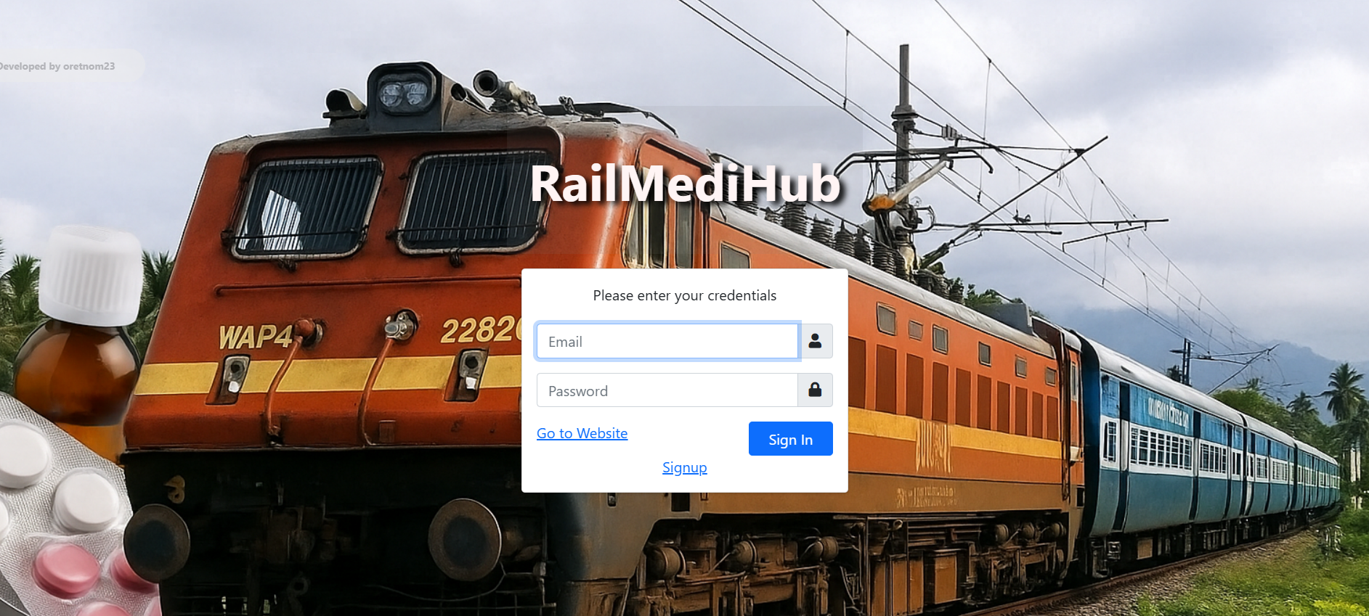

**b. Main Screen / Home Page**

**Description:**

* The home page of RailMediHub presents a clean and user-friendly interface with a prominent red navigation bar at the top.
* The navigation bar includes links to **Home**, **Products**, **About**, **Contact Us**, and user-related options like **Login**, **Register**, and **Admin Panel**.
* A large carousel section showcases images related to medicines, promoting the platform’s core purpose—medicine delivery.
* Below the banner, featured medicines are displayed with product images, names, brands, available stock, and prices.
* A button labeled **"Explore More Product"** encourages users to browse the full medicine catalog.
* The layout is designed to quickly inform users about available products and guide them to take further action like viewing details or placing orders.

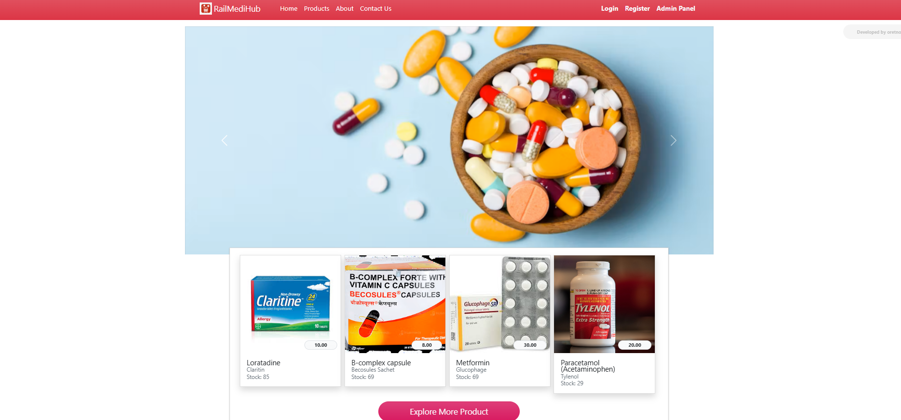.

**c. Menu**

**Description:**

* The menu is located at the top of the page and features a red gradient background with white text, providing a clean and professional appearance.
* On the left, the RailMediHub logo and name are prominently displayed, reinforcing the brand identity.
* The navigation links include Home, Products, About, Contact Us, and Cart, allowing easy access to major sections of the site.
* On the right side, the logged-in user's name (Vivek Khainoor) is displayed alongside a profile icon, indicating active session and user personalization.
* The dropdown arrow next to the username likely provides access to user-specific options such as profile, orders, or logout.



**d. Data Store / Retrieval / Update**

**Description:**

* Data Store:
  + Saves new information to the database (e.g., adding new medicines or placing an order).
  + Ensures the data is available for future access and use.
* Data Retrieval:
  + Fetches existing data from the database (e.g., displaying a list of available medicines or user orders).
  + Allows users to view relevant data based on their interactions.
* Data Update:
  + Modifies existing data in the database (e.g., updating stock quantities after an order is placed).
  + Ensures the data remains accurate and current.

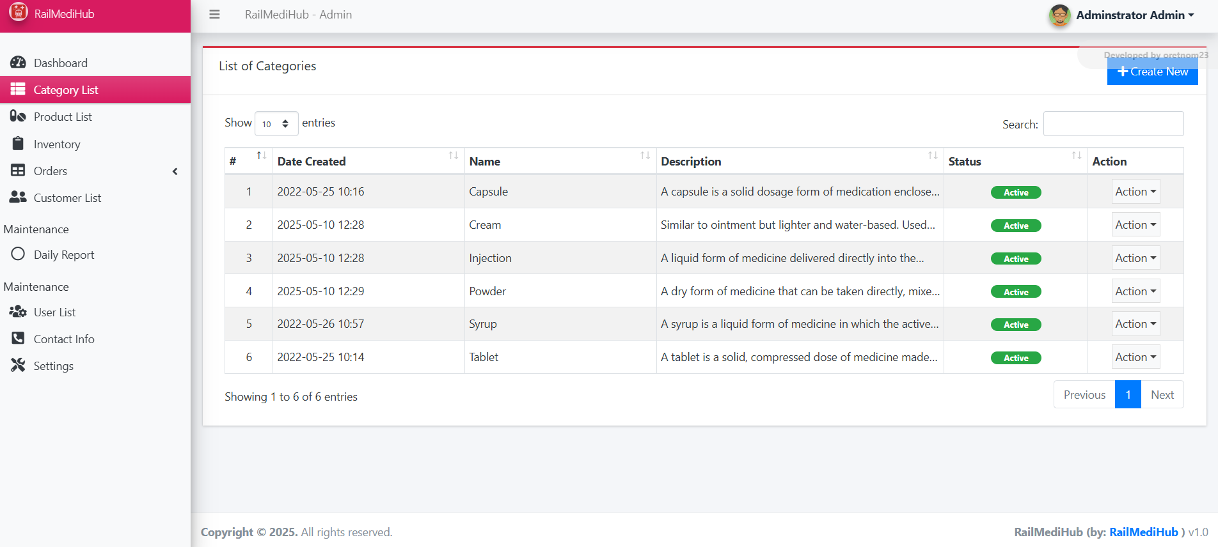

**e. Validation**

**Description:**

**Types of Validation:**

1. **Client-Side Validation**:
   * Performed in the user's browser before the data is submitted to the server.
   * Uses JavaScript to check inputs like required fields, correct data types (e.g., numbers for quantity), or valid email addresses.
   * 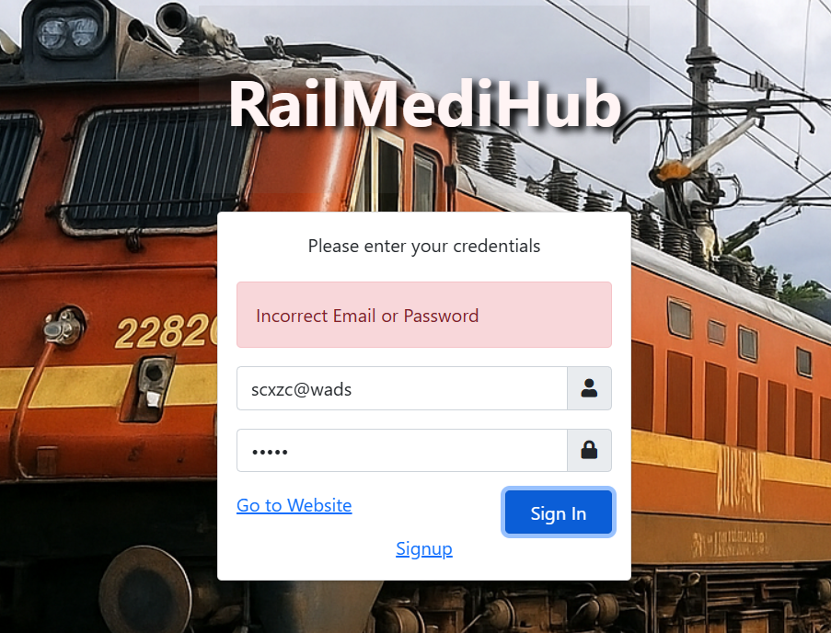Helps provide instant feedback to users, improving user experience.
2. **Server-Side Validation**:
   * Performed on the server after the data has been submitted.
   * Ensures that the data is valid before it is processed or saved into the database.
   * 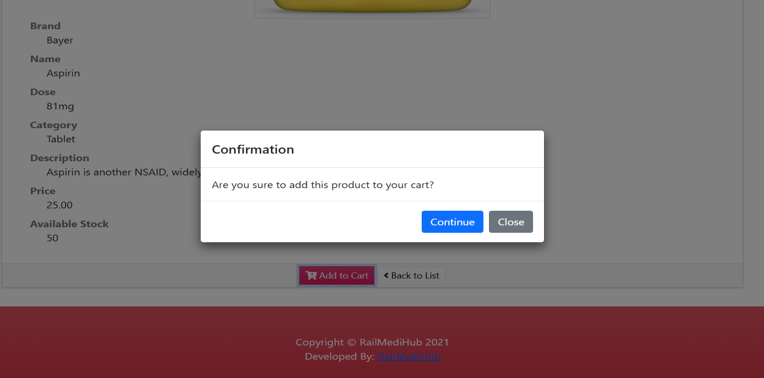Handles complex validation rules that may require access to the database (e.g., checking if a medicine is in stock).

**f. View**

**Description:**

* **Data Presentation**: Displays information from the database.
* **User Interaction**: Lets users interact (e.g., place orders).
* **Feedback**: Provides messages like confirmations or errors.

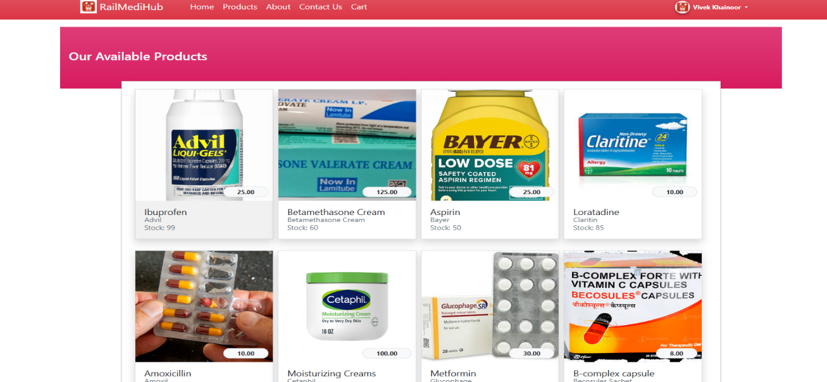

**g. On-Screen Reports**

**Description:**

* **Order Report**: Displays all orders with details like order ID, medicine name, quantity, and status.
* **Medicine Stock Report**: Shows available medicines and stock levels for admin monitoring.
* **Sales Summary Report**: Summarizes total orders and revenue over a selected period.
* 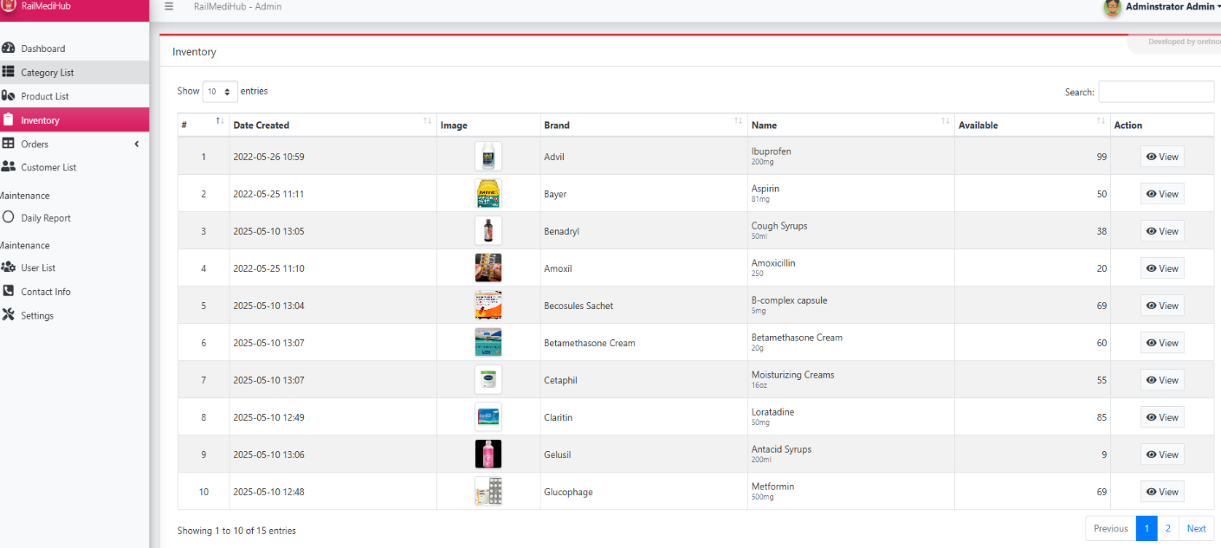**Medicine Availability Report**: Highlights medicines that are low in stock or unavailable.

**h. Data Reports**

**Description:**

* **User Order Report**:
  + Lists all orders placed by users with details like medicine name, quantity, date, and status.
* **Medicine Inventory Report**:
  + Displays current stock levels of all medicines for inventory tracking.
* **Sales Report**:
  + Summarizes total orders and revenue within a selected time frame (daily, weekly, monthly).
* **Out-of-Stock Report**:
  + Shows medicines that are low or out of stock to alert admins for restocking.

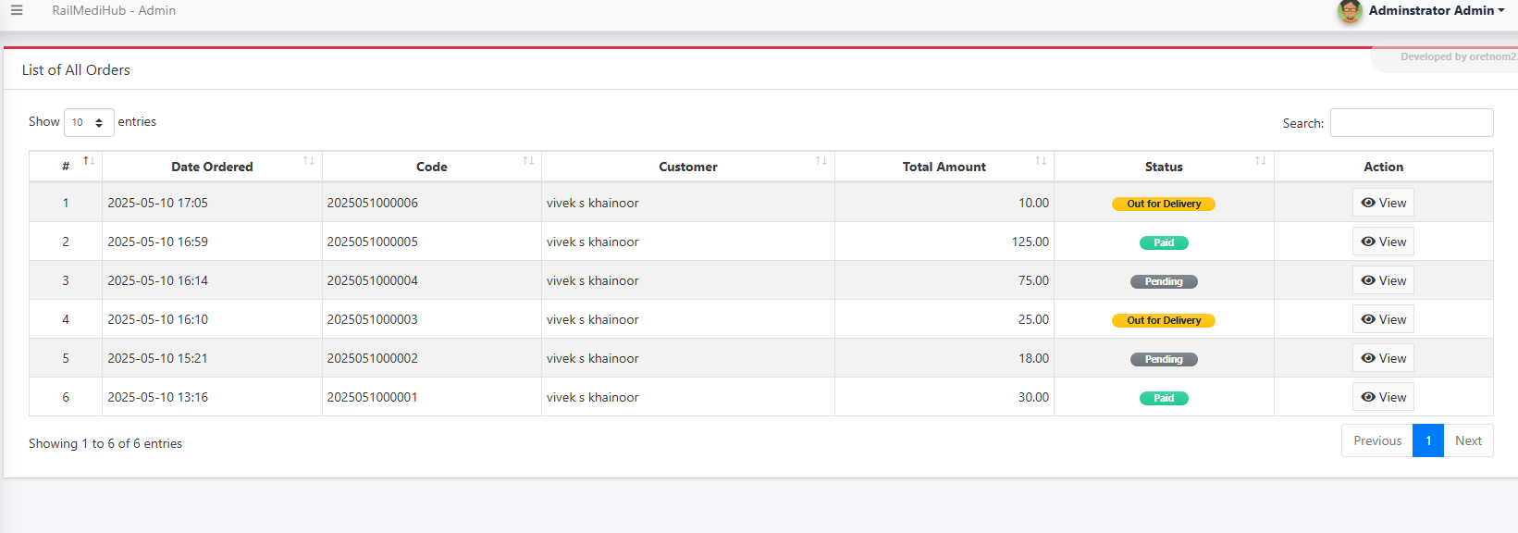

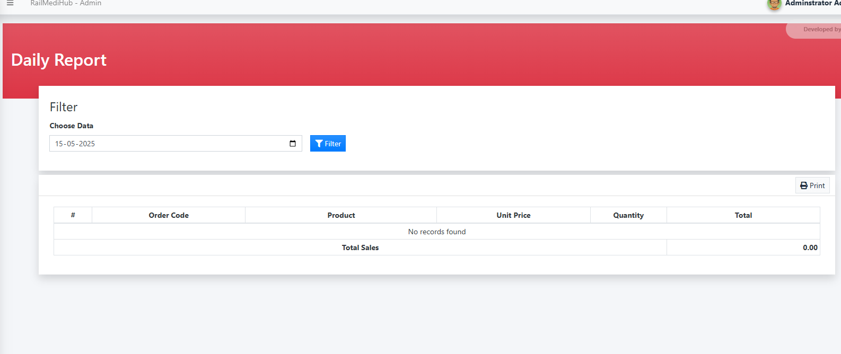

**i. Alerts**

**Description:**

* **Order Confirmation Alert**:
  + Shown when a user successfully places an order.
* **Low Stock Alert**:
  + Notifies admin when a medicine’s stock falls below a set limit.
* **Out-of-Stock Alert**:
  + Alerts users that a selected medicine is currently unavailable.
* **Order Status Alert**:
  + 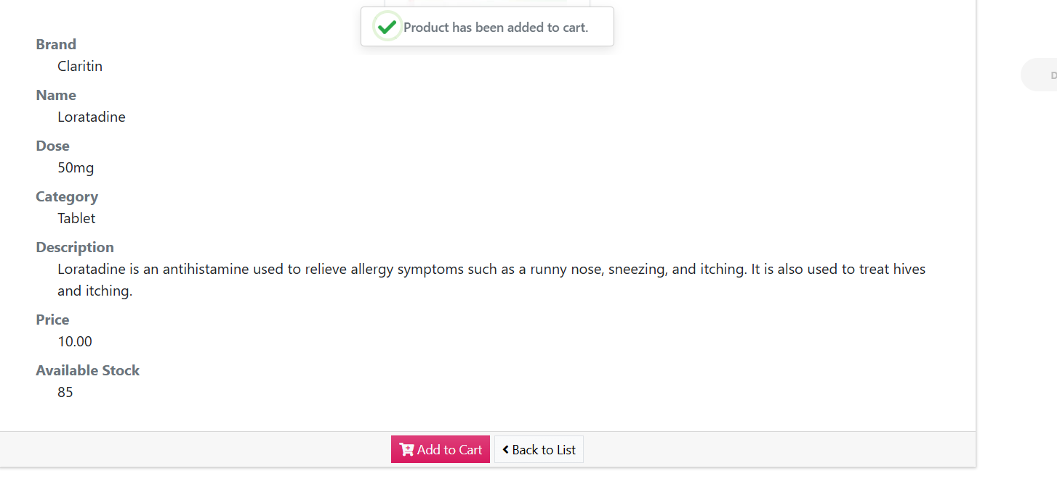Informs users when their order status changes (e.g., "Order Shipped" or "Delivered").

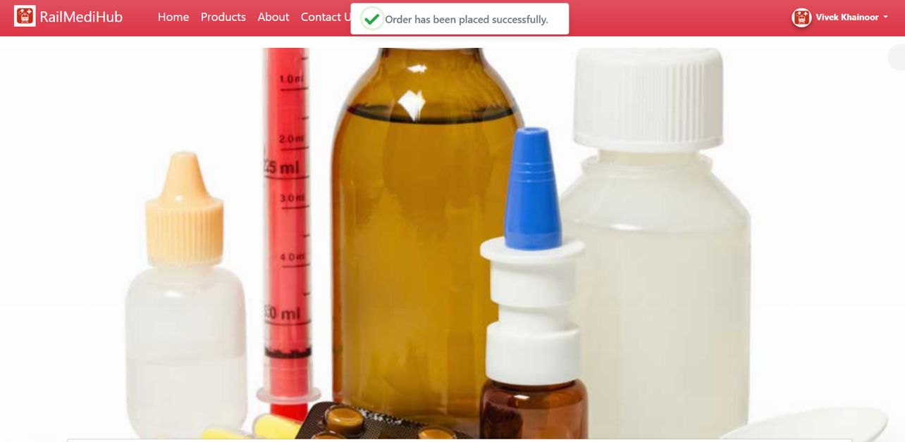

**j. Error Messages**

**Description:**

* **"Required Fields Cannot Be Empty"**  
  – Shown when a user submits a form without filling mandatory fields.
* **"Invalid Input Format"**  
  – Triggered when data like phone numbers or email addresses are entered incorrectly.
* **"Medicine Out of Stock"**  
  – Appears when a user tries to order a medicine that’s unavailable.
* **"Database Connection Failed"**  
  – Indicates a backend/server issue in accessing the database.
* **"Order Failed – Please Try Again"**  
  – Shown when the order process fails due to server or validation issues.



**Testing**

**a. Introduction**   
Software Testing is the process of evaluating a software application to identify any defects and ensure that it meets the specified requirements. It verifies that the system performs as expected and helps maintain software quality by preventing bugs and improving system reliability.

**i. Unit Testing**  
Unit testing focuses on testing individual components or modules of the system in isolation. For this project, each feature like Add to cart, order placement, and stock update was tested separately to ensure they perform their intended functions.

**ii. Integration Testing**  
Integration testing checks the interaction between different modules. In RailMediHub, this included verifying whether the connection between the medicine module and the order module worked properly, and whether database updates reflected correctly across the system.

**iii. System Testing**  
System testing involves testing the complete and fully integrated application. It ensures that the system meets all functional and non-functional requirements. This includes testing UI responsiveness, database operations, user actions, and report generation.

**b. Test Reports**

Sample test cases were created and executed manually. Below are key test outcomes:

* **Medicine Order Module** – Passed: Orders placed successfully, and stock updates correctly.
* **Medicine Listing Module** – Passed: Displayed all available medicines with updated data.
* **Input Validation** – Passed: Errors shown for empty or incorrect fields.
* **Database Testing** – Passed: Data stored, retrieved, and updated correctly

**Conclusion**

The RailMediHub Assistance System was developed to provide an efficient and convenient platform for users to order and receive medicines through railway services. Throughout the development lifecycle, various phases such as planning, designing, coding, and testing were carefully carried out to ensure the system's functionality and reliability.

The system successfully enables users to browse medicines, place orders, and view order status, while the backend manages data storage, stock updates, and report generation. Testing played a crucial role in validating each component and identifying errors early, which led to significant improvements in the overall system performance.

By leveraging technologies such as HTML, CSS, JavaScript, PHP, and MySQL, the project delivers a responsive and user-friendly interface with a functional backend. the system lays a strong foundation for future enhancements.

Overall, the project fulfills its objective of assisting with medicine delivery through a structured and systematic approach. It highlights the practical application of software development skills and demonstrates the potential for technology to improve essential services like healthcare delivery in rural or remote areas using existing transport infrastructure.

This system can serve as a starting point for a more advanced and scalable application in the future.

**Limitations:**

* No real-time train tracking API is integrated.
* No user login or authentication module is implemented.
* No payment gateway is included for online transactions.

**Future Scope**

**Scope for Enhancement (Future Scope):**

* Integrating real-time train tracking for accurate delivery estimation.
* Adding user authentication for secure access.
* Enabling online payment options for user convenience.
* Implementing SMS/email alerts for order updates.

**Abbreviations and Acronyms**

**UI** – User Interface

**UX** – User Experience

**SRS** – Software Requirements Specification

**SQL** – Structured Query Language

**DBMS** – Database Management System

**HTML** – Hypertext Markup Language

**CSS** – Cascading Style Sheets

**JS** – JavaScript

**GPS** – Global Positioning System

**HTTP** – HyperText Transfer Protocol

**HTTPS** – HyperText Transfer Protocol Secure

**JSON** – JavaScript Object Notation

**SSL** – Secure Socket Layer

**CRUD** – Create, Read, Update, Delete

**MVC** – Model View Controller

**DNS** – Domain Name System

**PHP** – Hypertext Preprocessor

**XML** – eXtensible Markup Language

**DB** – Database

**Bibliography/References**

**Bootstrap Documentation –** <https://getbootstrap.com/docs/>

**HTML & CSS W3Schools Guide –** [https://www.w3schools.com/](http://www.w3schools.com/)

**PHP Manual** – [www.php.net](http://www.php.net)

**MySQL Documentation** – <https://dev.mysql.com/doc>

**JavaScript.info** – <https://javascript.info>